Practical No: 06
Aim:Cross-Browser Testing Using Selenium Grid Tool: Selenium Grid Execute automation scripts across multiple browsers (Chrome, Firefox, Edge) using Selenium Grid. Compare execution time and compatibility issues.
In Eclipse:Create Selenium Project
OPEN ECLIPS:FILE NEW JAVA PROJECT ADD PCKAGE CLASS FILE
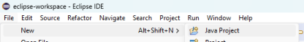Make package
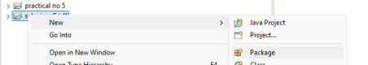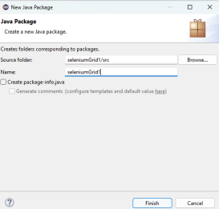
• Make two classes
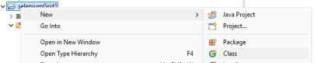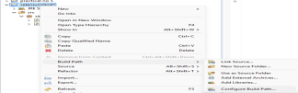
• Add External Jars
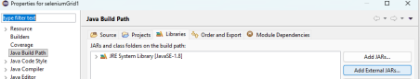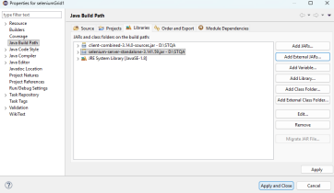package seleniumGrid1;
import java.net.URL;
import org.openqa.selenium.WebDriver;
import org.openqa.selenium.chrome.ChromeOptions;
import org.openqa.selenium.firefox.FirefoxOptions;
import org.openqa.selenium.edge.EdgeOptions;
import org.openqa.selenium.remote.RemoteWebDriver;
public class grid3 {
public static void main(String[] args) throws Exception { String[] browsers = {"chrome", "firefox", "edge"}; for (String browser : browsers) {
WebDriver driver;
if (browser.equals("chrome"))
driver = new RemoteWebDriver(
new URL("http://localhost:4444"),
new ChromeOptions());
else if (browser.equals("firefox"))
driver = new RemoteWebDriver(
new URL("http://localhost:4444"),
new FirefoxOptions());
else
driver = new RemoteWebDriver(
new URL("http://localhost:4444"),
new EdgeOptions());
long start = System.currentTimeMillis();
driver.get("https://www.selenium.dev/");
System.out.println(browser + " : " + driver.getTitle());
long time = System.currentTimeMillis() - start;
System.out.println("Time: " + time + " ms");
driver.quit();
}
}
}


